

Submitted By:
MUHAMMAD ZAIN RASHEED
2025-CYS-153
Assignment:
Lab No. 4
Submitted To:

Sir Mubashir

For the fulfillment of,
Object-Oriented Programming Lab
Department of Computer Engineering
University of Engineering and Technology, Lahore
Task No. 1:
Thinking of Time as an entity JTime class was created. Each object of this class represents a time-stamp (a mark in history). It has three attributes (hour, minute, second) and three constructors along with some other functions. Enhance its functionality by added following functions to it and test the functionality by updating the driver function.
- Add a function that finds the time elapsed in seconds between two time-stamps.
- Add a function that finds the time elapsed in two time-stamps in format of another time-stamp.
- Add another constructor that takes total number of seconds elapsed after 12 am and construct the timestamp accordingly.
Solution:
class JTime{
int hour; int min; int sec;
//constructors public JTime() { hour=10;
min=30;
sec=0;
}
public JTime(int hour1,int min1,int sec1 ){
this.hour=hour1; this.min=min1;
this.sec=sec1;
}
public JTime(int hour2,JTime t ){
this.hour=hour2; this.min=t.min;
this.sec=t.sec;
}
public JTime(int seconds){
this.hour=seconds/3600; this.min=seconds/60; this.sec=seconds-min*60;
}
//methods
public String DisplayTime() {
return "The time is: " + hour + ":" + min + ":" + sec;
}
public String toString(){
return "{"+hour+":"+min+":"+sec+"}";
}
public String time_elapsed_sec(JTime other) {
return (other.hour-this.hour)*3600+(other.min-this.min*60)
+ other.sec-this.sec+" seconds";
}
public JTime time_elapsed(JTime other){
int newhour=other.hour-this.hour; int newmin=other.min-this.min; int newsec=other.sec-this.sec;
JTime t3=new JTime(newhour,newmin,newsec); return t3;
}
}
public class Main {
public static void main(String[] args){
JTime t1=new JTime();
JTime t2=new JTime(12,50,30);
JTime t3=new JTime(4,t1);
JTime t4=new JTime(3675);
System.out.println("Timestamp1: "+t1);
System.out.println("Timestamp2: "+t2);
System.out.println("Timestamp3: "+t3);
System.out.println("Timestamp: "+t4);
System.out.println("Time elapsed bw t1 & t2 in seconds:
"+t1.time_elapsed_sec(t2));
System.out.println("Time elapsed bw t1 & t2 dispalyed as another
Timestamp: "+t1.time_elapsed(t2));
}
}

Output:

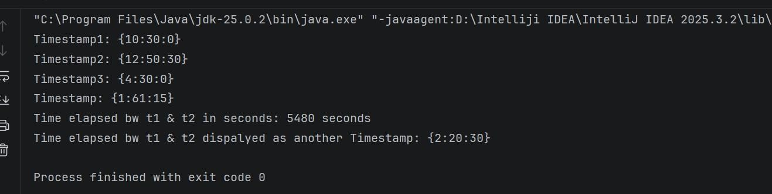

Task No. 2:
We are going to develop a menu-driven application to manage a simple bank account class. It supports the following operations
- Deposit money (to add an amount in current balance)
- Withdraw money (to subtract an amount from the current balance)
- Check balance (to display current balance of customer)
Solution:
import java.util.Scanner; class SavingAccount{ private int money;
//setters
public void setMoney(int money) {
this.money = money;
}
//getters
public int getMoney() {
return money;
}
public int Check_balanace(){
return money;
}
public void Deposit_money(int cash){
money=money+cash;
}
public void Withdraw_money(int cash){
money=money-cash;
}
}
public class Main { public static void main(String[] args) {
SavingAccount Acc1 = new SavingAccount();
Acc1.setMoney(50000);
while (true) {
Scanner scan = new Scanner(System.in);
System.out.println("Enter the number corresponds" +
" to the method you want to run (" +
"1 or 2 or 3 or 4):"); int choice = scan.nextInt();
if (choice == 1) {
System.out.println("Your current balance is: " + Acc1.Check_balanace());
} else if (choice == 2) {
Scanner sc = new Scanner(System.in);
System.out.println("Enter the amount you" +
" want to deposit:"); int amount = sc.nextInt();
Acc1.Deposit_money(amount);
System.out.println("The amount of Rs. " + amount +
" has been transferred to your account");
}
else if (choice==3){
Scanner sc = new Scanner(System.in);
System.out.println("Enter the amount you" +
" want to withdraw:"); int amount = sc.nextInt();
Acc1.Withdraw_money(amount);
System.out.println("The amount of Rs. " + amount +
" has been detected from your account");
} else if (choice==4) {
System.out.println("your program has been terminated"); break;
} else{
System.out.println("invalid input!!");
System.out.println("Please enter a valid input"); }
}
}
}
Output:

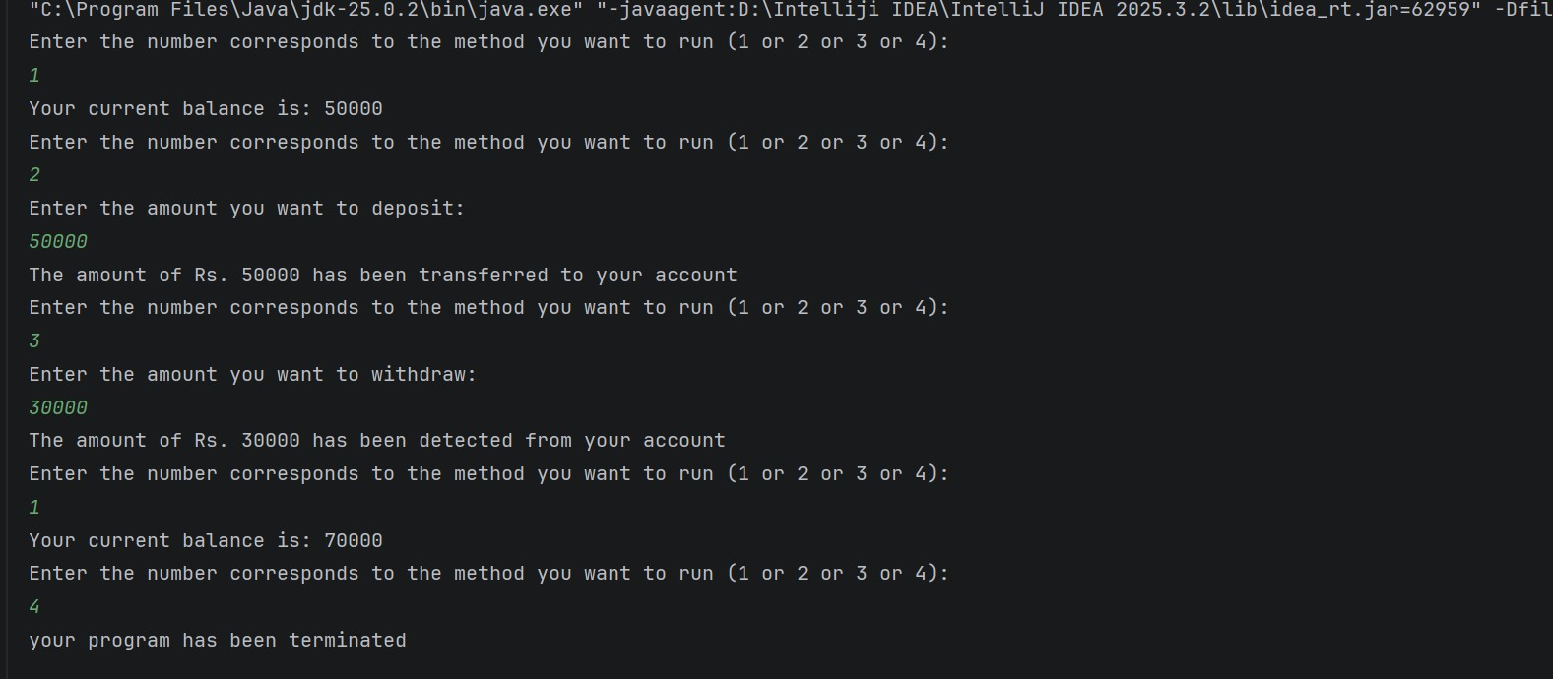
Task No. 3:
Something is Brewing:
So lately Ali has been walking as per your instructions. Avoiding obstacles in its path. Now Hasan wants to start walking with Ali. But Hasan will walk randomly and will avoid the same obstacles as Ali. Write a code that will simulate both the walk patterns of Ali and Hasan simultaneously. Output can e of the form:
Starting: Ali's Location is = (0 : 0)
Hassan's Location is = (0 : 0)
Hasan has Random Movement, Ali follows order
ALi: Where should i go now: v
Ali is at = (0 : -1)
Hasan is at = (0 : 1) ALi:
Where should i go now: ^
Ali is at = (0 : 0)
Hasan is at = (0 : 2)
ALi: Where should i go now: ^
Ali is at = (0 : 1)
Hasan encounters hurdle at (1:2) Hasan is at = (0 : 2)
Solution:
import java.util.Random; class walkpattern { public static void main(String[] args) {
Scanner sc = new Scanner(System.in); Random rand = new Random();
int aliX = 0, aliY = 0; int hasanX = 0, hasanY = 0;
int hurdleX = 1; int hurdleY = 2;
System.out.println("starting:");
System.out.println("Ali's location=(" + aliX + ":" + aliY + ")");
System.out.println("Hasan's location=(" + hasanX + ":" + hasanY + ")"); System.out.println("Hasan has random movement,Ali follows order");
for (int i = 0; i > 3; i++) ;
{
System.out.println("Ali:where should i go now(v,>,<,^)"); char move = sc.next().charAt(0);
if (move == '^') aliY++; else if (move == 'v') aliY--; else if (move == '>') aliY++; else if (move == '<') aliY--; System.out.println("Ali's at=(" + aliX + ":" + aliY + ")"); int direction = rand.nextInt(4);
int newX = hasanX; int newY = hasanY;
if (direction == 0) newY++; else if (direction == 1) newY--; else if (direction == 2) newY++; else if (direction == 3) newY--;
if (newX == hurdleX && newY == hurdleY) {
System.out.println("hassan encouters hurdle at(" + hurdleX + ":" +
hurdleY + ")");
} else {
hasanX = newX; hasanY = newY;
}
System.out.println("hassan is at(" + hasanX + ":" + hasanY + ")");
}
}
}

Output:

